**Using Patient Reported Outcomes to Estimate the Clinical Impact of Head and Neck Adaptive Radiation Therapy**

Sarah Weppler, MSca,b,*† ([Sarah.Weppler@albertahealthservices.ca](mailto:Sarah.Weppler@albertahealthservices.ca));

Harvey Quon, MD, MPHc,d ([Harvey.Quon@albertahealthservices.ca](mailto:Harvey.Quon@albertahealthservices.ca));

Colleen Schinkel, PhDb,d ([Colleen.Schinkel@albertahealthservices.ca](mailto:Colleen.Schinkel@albertahealthservices.ca));

Adam Yarschenko, BEngb,e ([Adam.Yarschenko@albertahealthservices.ca](mailto:Adam.Yarschenko@albertahealthservices.ca));

Lisa Barbera, MDc,d, ([Lisa.Barbera@albertahealthservices.ca](mailto:Lisa.Barbera@albertahealthservices.ca));

Demetra Yannitsos, MPHc,d ([Demetra.Yannitsos@albertahealthservices.ca](mailto:Demetra.Yannitsos@albertahealthservices.ca));

Nabhya Harjaif ([nabhya.harjai@ucalgary.ca](mailto:nabhya.harjai@ucalgary.ca));

Vicki Tranf ([vicki.tran@ucalgary.ca](mailto:vicki.tran@ucalgary.ca));

Peter Cheng ([pete.chen@ualberta.ca](mailto:pete.chen@ualberta.ca));

Wendy Smith, PhDa,b,d ([Wendy.Smith@albertahealthservices.ca](mailto:Wendy.Smith@albertahealthservices.ca))

a Department of Physics and Astronomy,

University of Calgary, 2500 University Dr NW, Calgary, Alberta, Canada T2N 1N4

b Department of Medical Physics,

Tom Baker Cancer Centre, 1331 29 St NW, Calgary, Alberta, Canada T2N 4N2

c Department of Radiation Oncology,

Tom Baker Cancer Centre, 1331 29 St NW, Calgary, Alberta, Canada T2N 4N2

d Department of Oncology,

University of Calgary, 2500 University Dr NW, Calgary, Alberta, Canada T2N 1N4

d Department of Mechanical Engineering,

University of Calgary, 2500 University Dr NW, Calgary, Alberta, Canada T2N 1N4

f Cumming School of Medicine,

University of Calgary, 2500 University Dr NW, Calgary, Alberta, Canada T2N 1N4

g Faculty of Medicine & Dentistry,

University of Alberta, 8440 112 St. NW, Edmonton, Alberta, Canada T6G 2R7

*Corresponding author. Department of Medical Physics, Tom Baker Cancer Centre, Canada.

†Responsible for statistical analysis.

**Disclosure of Conflicts of Interest:** The authors have no conflicts of interest to disclose.

**Funding Statement:** This work was supported in part by the Natural Sciences and Engineering Research Council of Canada (NSERC) – Canada Graduate Scholarship to S.W. NSERC had no involvement in either the conduct of the research or preparation of the article.

**Data Sharing Statement:** Research data are not available at this time.

**Using Patient Reported Outcomes to Estimate the Clinical Impact of Head and Neck Adaptive Radiation Therapy**

**ABSTRACT**

**Purpose: T**ext

**Methods:** Text

**Results:** Text

**Conclusions:** Text

**Keywords:** Patient-reported outcomes, adaptive radiation therapy, head and neck cancer

**INTRODUCTION**

ART is a resource-costly process. Doses can increase as a result of weight loss and tumor volume changes. We can correct dose but ultimately don’t know if this will result in a clinical benefit to patients. Patient-reported outcomes are increasingly important (Falchook *et al*) and provide a valuable way to estimate ART benefit.

ART and quality-of-life studies are rare. Yang *et al*. looked at quality of life outcomes for nasopharyngeal patients. This study is controversial given the potential bias introduced by the socioeconomic status of patients. Schwartz *et al*. asked ART patients to complete the MDADI but the study design did not allow conclusions to be drawn regarding whether ART improved quality of life results.

For this study, we look at whether quality of life summary scores and items may be improved with ART. This means first identifying which patient-reported symptoms worsen with increasing dose. In cases where dose is associated with patient-reported symptoms, we assess whether this association is stronger with planned or estimated delivered dose. We then use logistic regression to estimate the potential benefit of ART in these items. Patient selection for ART is challenging, so we also test if previous dose-based patient selection criteria translates to identify patients reporting severe symptoms.

**METHODS**

*Patients*

225 patients attending routine radiotherapy follow-up appointments between June and October 2019 completed a one-time PRO questionnaire. The questionnaire consisted of the MD Anderson Symptom Inventory for Head and Neck Cancer (MDASI-HN), the MD Anderson Dysphagia Inventory (MDADI), and Xerostomia Questionnaire (XQ). Patients included in this study received treatment with radical VMAT (chemo)radiotherapy (66-70 Gy in 30-35 fractions). Patients were excluded if they had a confirmed local-regional recurrence prior to survey completion. The final study cohort consisted of 155 patients.

Details regarding radiotherapy treatment at our centre have been previously described (Weppler *et al*.) and are summarized here. OAR planning objectives included: brainstem D0.03cc $≤$ 54 Gy; spinal cord D0.03cc $≤$ 45 Gy; pharyngeal constrictor Dmean $≤$ 50 Gy; and ipsilateral and contralateral parotid gland Dmean $≤$ 26 Gy. Treatments were planned using the Eclipse Treatment Planning System, Versions 11 and 13 (Varian Medical Systems, Palo Alta, CA). Institutional image-guided radiation therapy used daily kV-orthogonal imaging and weekly kV-cone beam CT (CBCT) imaging.

This study was approved by our institutional research ethics board (HREBA.CC-19-0119).

*Patient-Reported Outcome Instruments*

The MDASI-HN, MDADI, and XQ are validated PRO instruments (Cleeland *et al*., Rosenthal *et al*., Chen *et al.* 2001, Eisbruch *et al.*). The MDASI-HN consists of 28 questions assessing core symptoms (13 items), head and neck-specific symptoms (9 items), and symptom interference on daily life (6 items) (Cleeland *et al*., Rosenthal *et al.*). Each item is ranked from 0 (symptom not present) to 10 (symptom is as bad as you can imagine). Corresponding symptom burden is clinically interpreted as: none (item rating of 0); mild (1 to 4); moderate (5 to 6); or severe (7 to 10) (Cleeland *et al*.). Summary scores for each of the core, head and neck, and interference subgroups are defined by the maximum rating of any item within that subgroup. Subgroup symptom burden is interpreted as: none (all items rated 0); mild (all items rated <5 with at least one item rated $≥$ 1); moderate (all items rated <7 with at least one item rate $≥$ 5); severe (at least one item rated $≥$ 7) (Townes *et al*., Eraj *et al*., Gunn *et al*.).

The MDADI contains 20 questions assessing physical swallowing ability (8 items), functional impact of swallowing dysfunction (5 items), emotional impact (6 items), and the general influence of swallowing ability on daily life (1 item) (Chen *et al*.). Ratings for physical, functional, and emotional items are summed to produce the composite score (Chen *et al*.). Each item is rated on a 5-point Likert scale from Strongly Disagree to Strongly Agree. For this study, Likert-responses were converted to values from 1 to 5, summed, and normalized to 100 so that higher scores denoted more severe symptoms. This provided greater comparability with the MDASI-HN and XQ scoring systems. With this conversion, MDADI scores are interpreted as: minimal (summary score of 0 to 19), mild (20 to 39), moderate (40 to 59), severe (60 to 79), and profound (80 to 100) (Chen *et al*. 2009, Ortigara *et al*.).

The XQ is an 8-item assessment of xerostomia symptoms while eating (4 items) and while not eating (4 items). Item scores are totalled and normalized out of 100 (Eisbruch *et al*.).

*Data Collection – Chart Parameters, Planned Dose, and Estimated Delivered Dose*

Data for this study consisted of chart parameters (Table 1) and planned and delivered OAR dose parameter values. Previously validated deformable image registration workflows allowed us to estimate delivered OAR dose (Weppler *et al*.).

Using Mann-Whitney U tests and Fisher’s exact tests, we assessed whether chart parameters such as cancer site and performance status were significantly associated with PRO subgroups and individual items. PRO responses were divided into none/mild vs. moderate/severe categories (MDASI-HN responses <5 vs. $≥$ 5; MDADI responses <40 vs. $≥$ 40; XQ responses <50 vs $≥$ 50). Benjamini-Hochberg multiple testing corrections controlled the false discovery rate.

*Associations Between PROs and Dose*

. Kendall’s $τ$ tests assessed correlations between numerical PRO scores and corresponding OAR doses. For parotid glands, we stratified patients according to whether the minimum of ipsilateral and contralateral parotid gland doses exceeded the XX Gy planning objective. Mean PRO scores for each patient subgroup were compared using Mann-Whitney U tests. Odds ratios indicated whether patients with OAR dose exceeding the planning objective had an increased likelihood of reporting moderate/severe symptoms, with significance from Fisher’s exact test. Tests were repeated for planned dose and delivered dose.

*Estimating the Benefit of Adaptive Replanning*

For PRO items strongly associated with delivered dose, we estimated the potential effect of ART dose corrections on symptom severity. Patients were considered to have dose increases potentially correctable by replanning (“correctable increases”) if: their OAR dose was planned below the planning objective, but increased above the objective during treatment; their OAR dose was planned above the planning objective, and increased during treatment.

A previously published trend analysis for our deformable image registration workflow quantified the random error in estimated delivered dose. For example, increases in parotid gland dose exceeding 2.2 Gy, and increases in pharyngeal constrictor dose exceeding 0.75 Gy are likely to result from systematic changes in patient anatomy, rather than daily setup uncertainties or workflow error (Weppler *et al.*). Dose increases were adjusted to account for these tolerances; values greater than 0 indicate the potential correctability of systematic dose increases.

Logistic regression modeled the probability of moderate/severe symptom reporting vs. potentially correctable dose increases. These models allowed us to estimate the potential benefit, if any, of ART on patient-reported symptom severity.

*Patient Selection Criteria for Adaptive Radiation Therapy*

Recently, the literature has proposed criteria to select patients for adaptive replanning based on dose-correction goals (Weppler *et al.*). We tested the translatability of this criteria to PRO endpoints by examining its sensitivity and specificity in predicting patient reported moderate/severe symptoms.

All analyses were performed using R Version 3.6.0 (The R Foundation for Statistical Computing, Vienna, Austria). All statistical tests required p $≤$ 0.05 for significance.

**RESULTS**

*Patients and General Patient-Reported Outcome Results*

Cohort characteristics are provided in Table 1. Patients with lower initial BMI or poorer performance status reported more moderate/severe fatigue, sadness, poorer activity, greater interference with work, and poorer overall interference with daily life (p < 0.005). No statistically significant differences occurred in clinical parameters for other MDASI-HN, MDADI or XQ items or summary scores. 60 patients completed the PRO questionnaire within their first year after treatment (median = 7 months, range = 2-11 months), with the remaining 95 patients completing the questionnaire $≥$ 1 year post-treatment (28 months, 12-74 months).

Average $±$ SD summary scores for the MDASI-HN included: core - 5.1 $±$ 3.2 (53.2% of patients with moderate/severe scores); head and neck - 4.8 $±$ 3.2 (47.7%); and interference - 2.6 $±$ 2.8 (23.9%). The average scores of items within each subgroup were: 1.6 (SD = 2.6) for core items; 1.8 (2.7) for head and neck-specific items; and 1.4 (2.2) for interference items. Symptoms most highly rated by patients, in order of decreasing severity, included: dry mouth (mean $±$ SD = 4.3 $±$ 3.2, with 43.9% of patients reporting moderate/severe symptoms); taste (3.1 $±$ 3.0, 27.1%); mucus (2.7 $±$ 3.1, 25.8%); swallowing/chewing (2.7 $±$ 3.1, 24.5%); and fatigue (2.4 $±$ 2.8, 21.9%). The average score of all 28 MDASI-HN items was 1.6 (SD = 2.6).

The MDADI physical subgroup had the most severe ratings (mean $±$ SD = 48.0 $±$ 16.9, with 68.6% of patients reporting moderate/severe symptoms), followed by the general item (44.9 $±$ 25.1. 64.3%), composite score (44.2 $±$ 14.4, 59.5%), emotional subgroup (43.1 $±$ 15.0, 54.2%), and functional subgroup (39.5 $±$ 15.6, 49.7%). Total XQ scores averaged 33.7 (SD = 24.4) with 27.0% of patients having scores over 50.

*Associations Between PROs and Dose*

Table 2 summarizes the associations between PRO responses and dose. Stratifying patients according to whether their OAR doses were less than vs. greater than the planning objective revealed statistically significant differences in MDADI composite and physical summary scores. Mann-Whitney U tests indicated that patients with pharyngeal constrictor dose exceeding planning objectives reported higher MDADI scores in these subgroups. Odds ratios were statistically significant for composite and physical scores: patients with pharyngeal constrictor doses exceeding planning objectives had a greater odds of reporting moderate/severe symptoms. In addition, odds ratios associated with delivered doses exceeded those for planned doses, suggesting that that delivered dose may be more strongly associated with PRO scores in these subgroups.

Patients with parotid gland doses exceeding planning objectives had higher XQ scores, although this was not statistically significant. No significant associations between dose and MDASI scores were observed.

Cohort subgroups used to examine the association of PRO severity and dose were fairly balanced. For the pharyngeal constrictor, 53.5% of patients had planned doses exceeding the planning objective (overall cohort mean = 51.4 Gy; subgroup mean = 56.5 Gy), and 57.4% had delivered doses exceeding the planning objective (52.3 Gy; 57.1 Gy). For the parotid glands, 32.3% of patients had planned doses exceeding the planning objective (overall cohort mean = 23.7 Gy; subgroup mean = 30.8 Gy), and 44.5% had delivered doses exceeding the planning objective (25.1 Gy; 31.9 Gy).

Brainstem doses exceeded planning objectives for 3 patients at planning (overall cohort mean = 39.0 Gy; subgroup mean = 57.3 Gy) and 6 at delivery (39.4 Gy; 57.0 Gy). MDASI fatigue scores (Ferris *et al*.) were higher in patients where brainstem dose exceeded planning objectives (4.7 vs. 2.3 for planned dose; 3.7 vs. 2.3 for delivered dose), but conclusions were limited by small sample size. Spinal cord doses exceeded planning objectives in 11 patients at planning (overall cohort mean = 42.3 Gy; subgroup mean = 45.7 Gy) and 31 delivered (43.1 Gy; 46.3 Gy). but $≤$ 4 patients recorded moderate or severe

For patients with moderate/severe MDADI composite or physical scores, pharyngeal constrictor doses often exceeded the treatment planning objective, (fig 1). Although not statistically significant, similar dose and PRO associations were observed for MDASI-HN swallowing/chewing and choking/coughing items. Associations appear strongest among patients reporting $≥$ 1 year after treatment completion. Odds ratios for moderate/severe symptom reporting among these patients exceed that of the aggregate cohort for both the MDADI composite (planned dose: OR = 4.40; delivered dose: OR = 3.62) and MDADI physical subgroups (planned dose: OR = 4.06; delivered dose: OR = 3.18). No clear associations between parotid gland dose and patient-reported xerostomia symptoms were observed when considering patients in aggregate or according to <1 year vs. $≥$ 1 year durations since treatment completion.

*Estimating the Benefit of Adaptive Replanning*

Differences between planned vs. delivered pharyngeal constrictor doses are shown in Figure 2. 55.6% of patients exhibited increases in pharyngeal constrictor dose. 33.1% of patients had pharyngeal constrictor dose increases exceeding 1 Gy (mean = 1.8 Gy in this cohort subgroup); 8.5% with increases exceeding 2 Gy (mean = 2.8 Gy); and 3.5% with increases exceeding 3 Gy (mean = 3.5 Gy). Patients with moderate/severe MDADI scores $≥$ 1 year after treatment had the largest correctable dose increases (median = 0.8-1.0) (Figure 2). However, this was not statistically significantly different from patients reporting none/mild symptoms after $≥$ 1 year.

Figure 3 shows the modelled risk of patients reporting moderate/severe MDADI composite scores $≥$ 1 year post-treatment, with actual results. For every 1 Gy increase in dose, the risk of moderate/severe symptom reporting increased by 2.7%. Based on these models, we estimate that if doses were corrected back to baseline values, that a $≥$ 5% decrease in the risk of self-reported dysphagia would occur in 10.5% of patients, with a $≥$ 10% decrease in risk in 1.4% of patients. The model fit to MDADI physical scores is comparable, indicating a 2.2% decrease in risk per Gy dose correction.

*Patient Selection Criteria for Adaptive Radiation Therapy*

Selection criteria designed to identify patients with during-treatment increases pharyngeal constrictor dose is reproduced in Table 3 (from Weppler *et al*.). We examined the translatability of this dose-based criteria for predicting which patients would report moderate/severe MDADI summary scores $≥$ 1 year post-treatment. The criteria achieved sensitivity of 0.73 and specificity of 0.51 on MDADI composite responses, and sensitivity of 0.70 and specificity of 0.52 on MDADI physical responses (further examined in the Discussion).

**DISCUSSION**

Why this study is important. This study is important as it is the first to look at the benefit of replanning on patient-reported symptoms. ART focusses on xerostomia given how much the parotid glands shrink and shift during treatment. But for our cohort, the clearest benefit of ART was for patient-reported dysphagia symptoms. Dysphagia has been reported to worsen patient quality of life more than xerostomia (Ramaekers 2011, Hunter). Could be that parotid sparing has been such a focus for IMRT/VMAT that we already achieve maximum gains in QoL. Pharyngeal constrictor sparing is less common.

How this fits with the literature. Logistic regression results are consistent with literature for pharyngeal constrictor. Does proportion of patients reporting moderate/severe >1 year match the literature (e.g., 20%?) Why did we prioritize none/mild vs. moderate/severe – references from the literature. We looked at targeted items for each OAR, it is possible other correlations could be found but would have reduced statistical power. Need to cite why we looked at OAR specifically for each toxicity – pull thesis references. Consider studies reporting on dose vs. PROs; delivered dose vs. PROs. Hawkins et al look at dose and patient-reported xerostomia (abstract). ART studies by Yang et al vs. xerostomia. Chera et al look at combined parotid gland dose and propose new dose parameters see a dose association between PG and patient reported xerostomia with the PRO-CTCAE – more of their patients reported dysphagia symptoms than xerostomia. Dose was most important for xerostomia as in Lee 2014. Objective measures of parotid saliva flow were most strongly associated with dose (Miah). QoL data showed a low degree of dysphagia relative to objective measures – to explain the high proportion of patients reporting moderate/severe MDADI symptoms? (Mortensen)

Significance may be limited by PRO instrument. MDADI may have worked because multiple questions asked about a specific impact of swallowing, questions are very specific. Results are likely more robust than single MDASI items. Proportions are different so may have improved statistical power. MDASI large standard deviations potentially confounded statistical significance Discrete MDASI and XQ scores is likely to have increased standard deviation. But these surveys have been validated and used extensively. Scores may be less for delivered dose exceeding the planning objective as it included original patients planned above the objective plus those with lower scores slightly increasing above the objective (including more lower-dose cases 54.1). we see this for brainstem and PC $≥$ 1 year. Planning objectives and sparing goals evolve, which may explain the proportions of patients exceeding planning objectives. PG and PC sparing is secondary to target coverage.

Some crossover of dry mouth symptoms and MDADI – PG linked to MDADI scores. Patient interpretation of questions, acute xerostomia leading to dysphagia, or dose to salivary glands correlated with pharynx. Strong correlation between pharyngeal constrictor and minPG doses (tau and pvalue for this). Dysphagia primarily associated with pharyngeal constrictor so focussed on this. Parotid glands showed a dose dependence vs. MDADI items. Acute xerostomia and acute dysphagia are strongly predictive of late dysphagia (van der Laan 2015). Dose should be limited to both the parotid glands and pharyngeal constrictor to improve dysphagia incidence. Focused on PCs as dose association was visible with MDASI and MDADI items. Ips PG dose generally higher but a few exceptions (# and average).

Comment on brainstem/spinal cord. Previous studies have predicted weight loss as an ART intervention endpoint. BMI was associated with interference items, not specific toxicities so fell outside of the scope of this study.

Limitations: only calc on last CBCT, no dose accumulation. Here dose is recalculated on the final CBCT with total dose applied. No baseline. Assuming that this is representative of delivered dose. Dose changes are often seen in 1st half of treatment so perhaps reasonable surrogate but need to justify. Further trend analyses are required. Dose accumulation would help. Pharyngeal constrictor contouring variability is a confounding factor, especially with PTV near/within the pharyngeal constrictor. Looked at minimum PG dose. Potentially confounded by ips./cont. We tested both independently but similar results though this could possibly confound results. We looked at minimum PG dose as closest to that implemented with our planning objectives (spare at least one <26 Gy). Inferred cutpoint of 50 for XQ. Motivates a look at cross-walks among H&N PRO instruments. Associations between PRO scores and OAR dose for this patient subgroup was a priority (<1 year vs. >1 year). ART where it would have the most benefit in long-term symptom reduction. Hard to tell which transient symptoms would become lasting. Longitudinal studies would be needed to clarify this. >1 year prioritized in ART protocols (mentioned in Methods). We didn’t look at submandibular glands (like Lee 2015) due to DIR noise in estimated delivered doses. Xerostomia may result from dose to oral cavity (not routinely contoured) and submandibular glands (Little). Only looked at pharyngeal constrictor for swallowing also parts of the PC, larynx future studies can look at these, doses likely correlated. Patient-reported dysphagia cannot be interchanged with clinical measures of dysphagia (Pedersen)

Sample size here too small to produce new patient selection models but would be important for future work. PRO data is quite noisy, so possible that sample size would need to be larger than for the dose study. Reapplying the dose-based criteria. Applicability of patient selection criteria still limited by specific practices at our centre. Using the patient selection criteria, performance is perhaps not strong enough to be used clinically but shows promise that late dysphagia can be predicted. For comparison, Weppler *et al* found that the criteria could predict dose violations on an external validation set with sensitivity of 0.84 and specificity of 0.68. PROMs are generally noisier data, so maintaining predictions based on dose may be more robust. Larger studies may further investigate ART modeling developed specifically for PROM endpoints in the future. Sensitivity was prioritized in the development of the patient selection criteria, reflected in the better sensitivity observed here. Indicates the need for dose-based ART but QoL criteria should replace this when robust models are developed.

**CONCLUSION**

**REFERENCES**

1. Chen AY, Frankowski R, Bishop-Leone J, *et al*. The Development and Validation of a Dysphagia-Specific Quality-of-Life Questionnaire for Patients With Head and Neck Cancer*. Arch Otolaryngol Head Neck Surg.* 2001;127:870-876.
2. Chen PH, Golub JS, Hapner ER, Johns MM. Prevalence of Perceived Dysphagia and Quality-of-Life Impairment in a Geriatric Population. *Dysphagia*. 2009;24:1-6.
3. Cleeland CS, Mendoza TR, Wang XS, *et al*. Assessing Symptom Distress in Cancer Patients: The M.D. Anderson Symptom Inventory. *Cancer*. 2000;89:1634-1646.
4. Eisbruch A, Kim HM, Terrell JE, Marsh LH, Dawson LA, Ship JA. Xerostomia and its predictors following parotid-sparing irradiation of head-and-neck cancer. *Int J Radiat Oncol Biol Phys*. 2001;50(3):695-704.
5. Eraj SA, Jomaa MK, Rock CD, *et al*. Long-term patient reported outcomes following radiation therapy for oropharyngeal cancer: cross-sectional assessment of a prospective symptom survey in patients $≥$ 65 years old. *Radiat Oncol*. 2017;12:150.
6. Ferris MJ, Zhong J, Switchenko JM, *et al*. Brainstem dose is associated with patient-reported acute fatigue in head and neck cancer radiation therapy. *Radiother Oncol*. 2018;126(1):100-106.
7. Gunn GB, Hansen CC, Garden AS, *et al*. Favorable patient reported outcomes following IMRT for early carcinomas of the tonsillar fossa: Results from a symptom assessment study. *Radiother Oncol*. 2015;117:132-138.
8. Hunter KU, Schipper M, Feng FY, *et al*. Toxicities Affecting Quality of Life After Chemo-IMRT of Oropharyngeal Cancer: Prospective Study of Patient-Reported, Observer-Rated, and Objective Outcomes. *Int J Radiat Oncol Biol Phys*. 2013;85(4):935-940.
9. Hutcheson KA, Portwood M, Lisec A, Barringer DA, Gries K, Lewin JS. What is a Clinically Relevant Difference in MDADI Scores between Groups of Head and Neck Cancer Patients? *Laryngoscope*. 2016;126(5):1108-1113.
10. McDowell L, Casswell G, Bressel M, *et al*. Patient-reported quality of life and toxicity in unilateral and bilateral radiotherapy for early-stage human papillomavirus associated tonsillar carcinoma. *Clin Transl Radiat Oncol.* 2020;21;85-90.
11. Memtsa PT, Tolia M, Tzitzikas I, *et al*. Assessment of xerostomia and its impact on quality of life in head and neck cancer patients undergoing radiation therapy. *Mol Clin Oncol*. 2017;6:789-793.
12. Ortigara GB, Schulz RE, Soldera EB, *et al*. Association between trismus and dysphagia-related quality of life in survivors of head and neck cancer in Brazil. *Oral Surg Oral Med Oral Pathol Oral Radio*. 2019;128:235-242.
13. Petkar I, Bhide S, Newbold K, Harrington K, Nutting C. Dysphagia-optimised Intensity-modulated Radiotherapy Techniques in Pharyngeal Cancers: Is Anyone Going to Swallow it? *Clin Oncol*. 2017;29:110-118.
14. Rosenthal DI, Mendoza TR, Chambers MS, *et al*. Measuring head and neck symptom burden: The development and validation of the M.D. Anderson Symptom Inventory, Head and Neck Module. *Head Neck*. 2007;29:923-831.
15. Sapir E, Tao Y, Feng F, *et al*. Predictors of dysgeusia in Patients With Oropharyngeal Cancer Treated With Chemotherapy and Intensity Modulated Radiation Therapy. *Int J Radiat Oncol Biol Phys*. 2016;96(2):354-361.
16. Townes TG, Navuluri S, Pytynia KB, *et al*. Assessing patient-reported symptom burden of long-term head and neck cancer survivors at annual surveillance in survivorship clinic. *Head Neck*. 2020:1-9.
17. Weppler S, Quon H, Schinkel C, *et al*. Using artificial intelligence to derive patient selection criteria for adaptive radiation therapy. (In Review.)

Table 1: Cohort demographic and clinical characteristics

|  |  |
| --- | --- |
| Parameter | Full Cohort (n = 155) |
| Age in years, mean ($±$ SD) | 57.4 (10.9) |
| Gender, number (%)  Male  Female | 131 (84.5%)  24 (15.5%) |
| Initial BMI, mean ($±$ SD) | 28.1 (5.6) |
| ECOG, median (range) | 1 (1-3) |
| Charlson Comorbidity Index, median (range) | 4 (2-8) |
| Alcohol use, number (%)  Never  Former  Current – Light (males 0-15 drinks/week, females 0-10 drinks/week)  Current – Heavy (males >15 drinks/week, females >10 drinks/week) | 36 (23.2%)  12 (7.7%)  83 (53.6%)  24 (15.5%) |
| Tobacco use, number (%)  Never  Cumulative – Light (0-20 pack-years)  Cumulative – Heavy (>20 pack-years) | 63 (40.7%)  43 (27.7%)  49 (31.6%) |
| Primary tumor location, number (%)  Larynx  Hypopharynx  Oral Cavity  Oropharynx  Nasal Cavity  Nasopharynx  Unknown | 7 (4.5%)  3 (1.9%)  3 (1.9%)  98 (63.3%)  7 (4.5%)  26 (16.8%)  11 (7.1%) |
| T stage, number (%)  T0 – T2  T3 – T4  Tx | 71 (45.8%)  73 (47.1%)  11 (7.1%) |
| N stage, number (%)  N0  N1  N2  N3  NX | 23 (14.8%)  34 (21.9%)  83 (53.6%)  14 (9.0%)  1 (0.7%) |
| p16 status, number (%)  Negative  Positive  Unknown | 21 (13.6%)  100 (64.5%)  34 (21.9%) |
| Chemotherapy agent, number (%)  Carboplatin  Cetuximab  Cisplatin (Cisplatinum)  None | 3 (1.9%)  13 (8.4%)  128 (82.6%)  11 (7.1%) |

Table 2: Comparison of patient-reported symptom scores and dose, reported as mean (SD)

|  |  |  |  |  |  |  |
| --- | --- | --- | --- | --- | --- | --- |
| Toxicity/ OAR | Relevant PROMs | Planned Dose | | Delivered Dose | | |
| ($<$ Obj. / $≥$ Obj.) | OR | | ($<$ Obj. / $≥$ Obj.) | OR |
| Xerostomia/ Parotid Glands | *MDASI Summary Scores and Relevant Items*  Core   * Dry Mouth   Head & Neck   * Swallowing/Chewing * Taste   Interference  *XQ Total Score* | 5.1 (3.2) / 4.9 (3.2)  4.3 (3.3) / 4.4 (3.2)  4.7 (3.2) / 5.0 (3.3)  2.6 (3.0) / 2.9 (3.2)  3.1 (3.1) / 3.3 (2.8)  2.7 (2.7) / 2.4 (3.0)  32.3 (23.4) / 37.2 (26.9) | -  -  -  -  -  -  - | | 5.3 (3.3) / 4.8 (3.0)  4.5 (3.4) / 4.1 (3.0)  5.0 (3.2) / 4.6 (3.2)  2.6 (3.1) / 2.7 (3.0)  3.2 (3.2) / 3.0 (2.7)  2.7 (2.9) / 2.4 (2.8)  32.8 (24.0) / 35.1 (25.4) | -  -  -  -  -  -  - |
| Dysphagia/ Pharyngeal Constrictor | *MDASI Summary Scores and Relevant Items*  Core  Head & Neck   * Swallowing/Chewing * Choking/Coughing * Taste   Interference  *MDADI Summary Scores*  Composite  Physical  Emotional  Functional  General | 5.1 (3.0) / 4.8 (3.3)  5.1 (3.1) / 4.5 (3.2)  2.6 (3.0) / 2.6 (3.0)  1.6 (2.4) / 1.9 (2.5)  2.9 (3.1) / 3.1 (3.0)  2.7 (2.8) / 2.4 (2.8)  **41.1 (14.9) / 45.9 (13.7)**  **44.7 (18.2) / 49.9 (16.2)**  40.2 (14.5) / 44.5 (14.9)  **36.5 (15.5) / 41.4 (14.9)**  40.7 (24.0) / 46.7 (24.6) | -  -  -  -  -  -  **2.30**  **2.15**  -  -  - | | 5.0 (2.9) / 4.9 (3.3)  5.0 (3.1) / 4.6 (3.2)  2.4 (2.9) / 2.7 (3.0)  1.7 (2.4) / 1.8 (2.5)  2.8 (3.1) / 3.2 (3.0)  2.8 (3.0) / 2.3 (2.7)  **40.6 (15.1) / 45.9 (13.6)**  **43.8 (17.4) / 50.1 (16.7)**  **39.7 (14.8) / 44.5 (14.7)**  **36.5 (17.1) / 41.1 (14.0)**  41.2 (24.9) / 46.1 (24.2) | -  -  -  -  -  -  **2.52**  **2.18**  -  -  - |

**Bold** entries indicate that mean values and odds ratios are statistically significant (p $≤$ 0.05) according to Mann-Whitney and Fisher’s Exact tests, respectively. Obj.: treatment planning dose objective. OR: odds ratio.

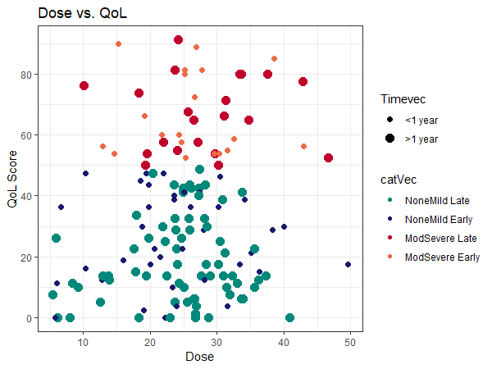

Delivered Dose to Parotid Glands (Gy)

XQ Total Score

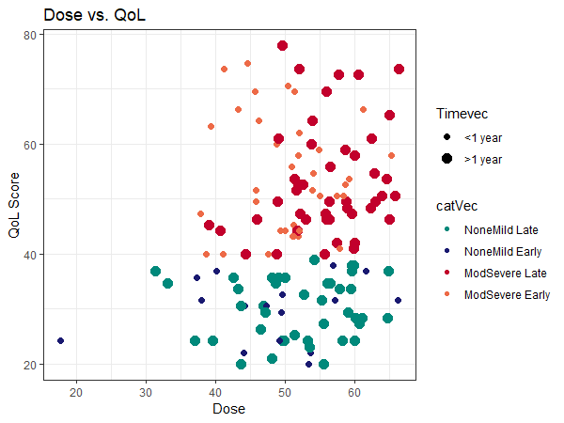

Delivered Dose to Pharyngeal Constrictor (Gy)

MDADI Composite Score

Delivered Dose to Pharyngeal Constrictor (Gy)

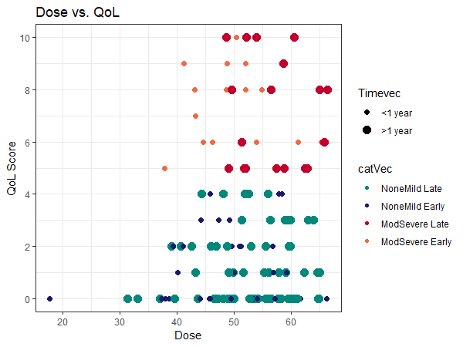

MDASI Swallowing/Chewing Item

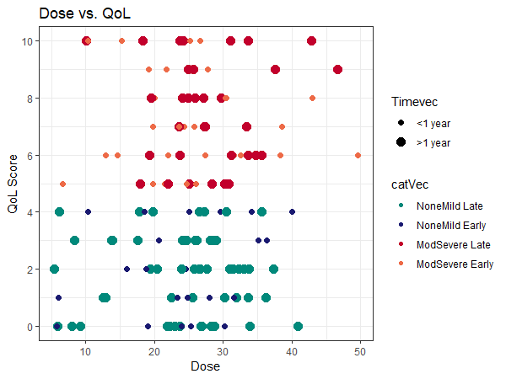

Delivered Dose to Parotid Glands (Gy)

MDASI Dry Mouth Item

Legend: None/Mild $<$ 1 year None/Mild $≥$ 1 year Moderate/Severe $<$ 1 year Moderate/Severe $≥$ 1 year

Figure 1: Examples of associations between PRO scores and delivered OAR doses. Top: Pharyngeal constrictor doses of patients reporting moderate/severe dysphagia symptoms generally exceeded the planning objective of 50 Gy. Bottom: The relationship between parotid gland dose and patient-reported xerostomia symptoms was less clear.

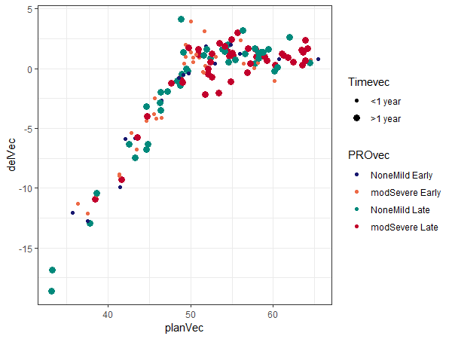

Planned Dose (Gy)

Potential Dose Correction (Gy)

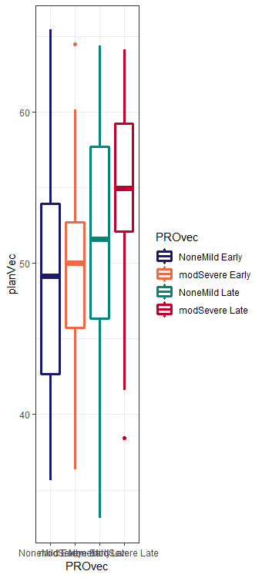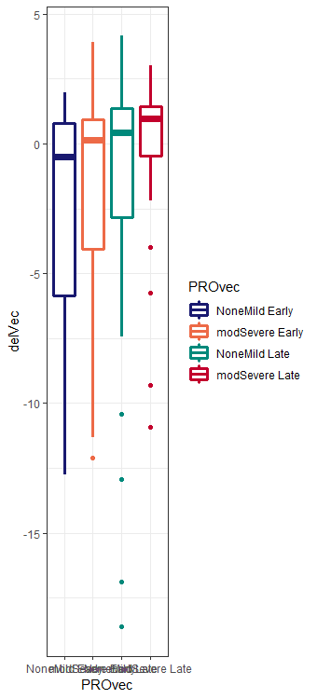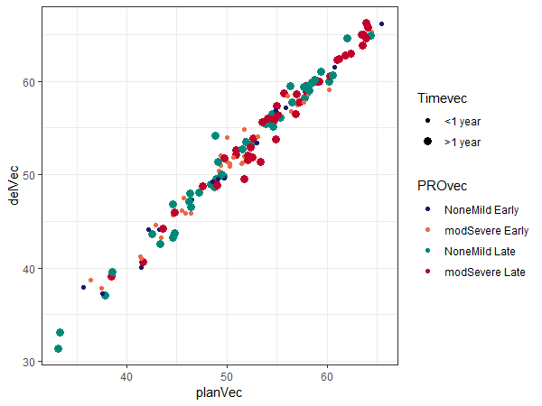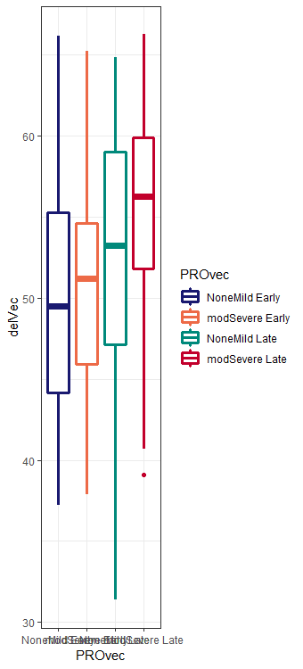

Planned Dose (Gy)

Delivered Dose (Gy)

Legend: None/Mild $<$ 1 year None/Mild $≥$ 1 year Moderate/Severe $<$ 1 year Moderate/Severe $≥$ 1 year

Figure 2: Differences in patient reported symptoms with respect to planned, delivered, and correctable increases in pharyngeal constrictor dose. Left: For the majority of patients, delivered pharyngeal constrictor doses exceeded planned doses. Right: Patients with moderate/severe symptoms persisting more than 1 year after treatment generally had the largest correctable dose increases. (To improve visualization, graphs above exclude an outlying patient with pharyngeal constrictor dose <20 Gy.)

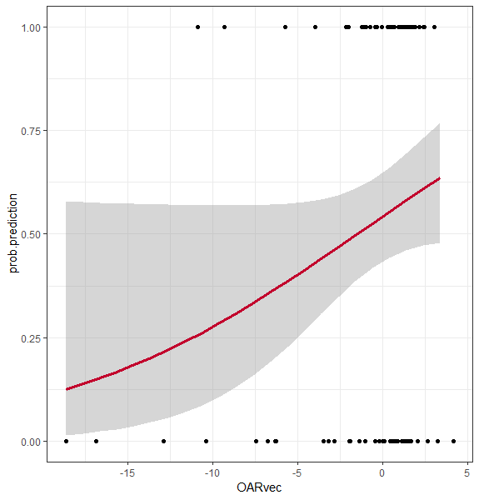

Potential Dose Correction (Gy)

Probability of Moderate/Severe MDADI Composite Scores $≥$ 1 year After Treatment

Figure 3: Logistic regression model of increases pharyngeal constrictor dose versus moderate/severe MDADI composite scores persisting $≥$ 1 year after treatment.

|  |  |
| --- | --- |
| Endpoint | Simple Patient Selection Criteria |
| Pharyngeal Constrictor | If **Planned brainstem D0.03cc $≥$ 16 Gy**  **AND Planned cont. parotid gland Dmean $≥$ 19 Gy**  **AND Planned cont. submand. gland Dmean $≥$ 34 Gy**  **AND Planned ips. parotid gland Dmean $≥$ 21 Gy**  **AND Planned pharyngeal constrictor Dmean $≥$ 49 Gy**  **AND Planned spinal cord D0.03cc $≥$ 40 Gy**  **AND Initial low-dose CTV volume $≥$ 197cc**  then violation likely. |

Table 3: Simple patient selection criteria to identify patients at risk of during-treatment increases in pharyngeal constrictor dose (reproduced from: Weppler *et al.* 2020)